Inserting Samm Template Merge Fields into Microsoft Word – Advanced

Contents
Introduction 1
Microsoft Word 1
Working with MS Word Merge Fields 1
Select a merge field 1
Delete a merge field 2
Copying a merge field 2
Editing a merge field 2
APE Word Add-in 2
Positioning Elements in Word using Tables 2
Positioning Elements on the page 2
Table Borders 3
Table Properties 3
Wrapping 3
Stopping Word from resizing columns 3
Text Alignment with Cells 4
Creating tick/cross boxes to contain merge fields 4
Question merge fields 4
Changing the display of answers to different text 5
Symbols 5
Working with merge fields inside small boxes 5

Introduction
When learning about templates making, it is best to start with the basics by doing the tutorial exercises at
https://support.damstratechnology.com/hc/en-us/articles/900001188466

In the 1st tutorial, step 2(C) is about inserting merge fields into Word documents using the APE Word Add-in, at
https://support.damstratechnology.com/hc/en-us/articles/900001188446

This document expands upon 2(C), giving details needed for more advanced use.

Microsoft Word
Templates use Microsoft Word DOCX (or DOC) files to control what the output PDF of forms will look like. Most people have access to Word and some familiarity with it. Word has rich functionality, so that provides a generally easy and accessible way for template administrators to change cosmetic details including fonts, formatting and logos. That richness can add complexity though. We use the Add-in to make it easy where we can, but there are areas of Word that can be a bit tricky or fiddly. It is necessary to learn not just about Samm templates but also some particular Microsoft Word functionality.

Working with MS Word Merge Fields
Beware: Don’t try to edit or delete merge fields as if they are ordinary text! Instead work with them as follows.

Select a merge field
Put the text cursor on the right-hand side of the merge field, and then press backspace. That selects it (pressing backspace *once* doesn't delete it).

Delete a merge field
If you want to delete a merge field then always select it first using the above. Pressing backspace a 2nd time (after selecting it) will delete it.

Copying a merge field
If you want to copy a merge field then always select it first as above.

Editing a merge field
We recommend that you don’t edit merge fields but you can do it follows:
1. Right-click on the merge field and choose to Toggle it.
2. Edit the ‘insides’ of the merge field carefully, if you don't get the contents exactly right then it won't work.
3. When you've edited the merge field, right-click on the merge field and choose to Update it.

APE Word Add-in
You can download the APE Word Add-in from https://support.damstratechnology.com/hc/en-us/articles/900001179346

In brief: Log into your Samm site in the Add-in and then left-click drag merge fields into the places in the DOCX where you want data from that field to appear.

If you edit the template, and want to see that change in the Add-in, then click “Save and Continue” in the template editor and then (when that has finished) click Refresh at the bottom of the Add-in.

After you’ve made changes to the DOCX, use the Add-in’s Preview button to check how the form would look as a PDF (with sample data that Samm automatically generates).

For further information about the Add-in's functionality please see the Add-in page above.

Positioning Elements in Word using Tables

Positioning Elements on the page
Use tables for positioning instead of tabs or spacing. That provides better control over positions, in a context in which the size of data (text and images coming through merge fields) is variable.

So, don’t do this:
Name: ___«Name»___________ Date of Birth ___«DOB»___________

Instead, do this:
Name: | «Name» |  | Date of Birth

To see the above 2 examples more fully, please:
- Turn on “View Gridlines”, using the button 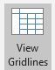 on Word’s 2nd Layout ribbon/menu, which only appears when the text cursor is inside a table. The green-coloured text above is in a table.
- Turn on Word’s display of hidden characters Tip: I use keyboard shortcut CTRL+SHIFT+8 to turn that on & off.
You might like to turn off Word’s display of hidden characters sometimes, to de-clutter what you’re looking at.

Table Borders
When using tables for positioning, if you don’t want to see their borders then make them hidden as shown:
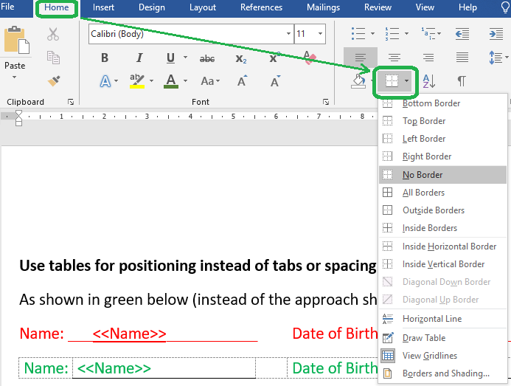

Table Properties

Wrapping
Ensure that your tables (or other elements like images) have their Text Wrapping property set to Around instead of None. Otherwise their position can change when being converted to PDF!
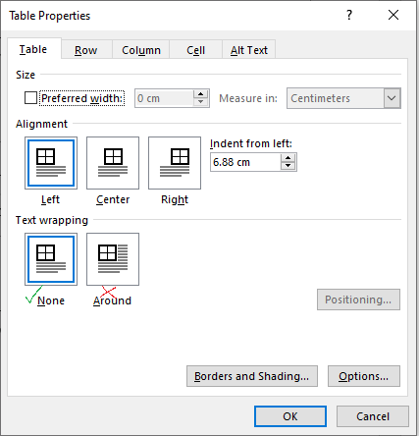

Stopping Word from resizing columns
If MS Word changes to size of columns/cells when you put data (like merge fields) into them then turn off the table property “Automatically resize to fit contents” as shown:
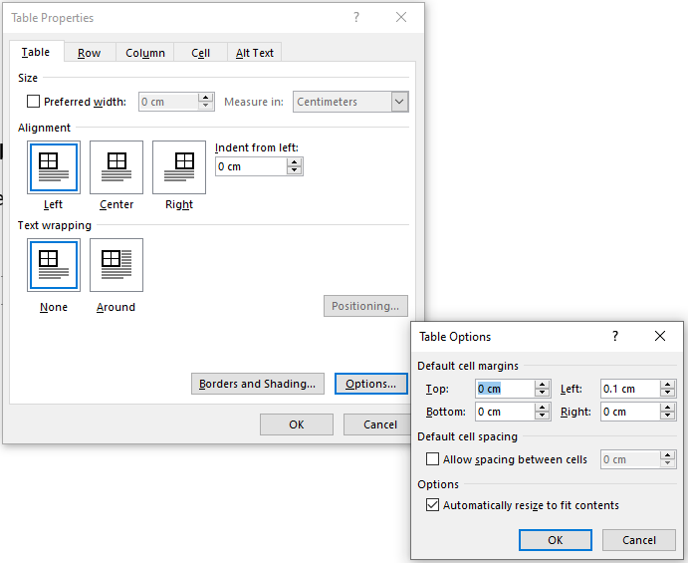

Text Alignment with Cells
To control where text sits within table cells, it is handy to use the Alignment buttons on Word’s 2nd Layout ribbon/menu (which only appears when the text cursor is inside a table) as shown:
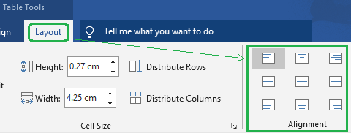

Creating tick/cross boxes to contain merge fields
When Samm templates have questions controls, like: Have you checked the safety valve? [YES] [NO]
then the question control’s merge field can be placed into a table cell in a simple way, to give a PDF appearance like this:
Have you checked the safety valve? | √

However, we often want to display the result looking nicer with a box around the tick (or cross) like this:
Have you checked the safety valve?
  √

We can do that in MS Word by inserting a 1x1 table inside the cell of a parent table, and then put the merge field into the 1x1 table. That works well but it is fiddly to get the best appearance by setting lots of details/settings. To save time, we recommend copy-and-pasting from a table that already has that set up, such as below:

Rough Terrain
Rigid / Tilt
Other Plant

NOTE:
- If you copy-and-paste 1 cell then it doesn’t work(!) but if you copy-and-paste more than one at a time then it works.
- If the DOCX that you are starting with contains other elements (like text boxes or symbols that look like boxes e.g. □) then delete those before doing the above.

Question merge fields
Question controls have more merge fields than other control types. They are explained at the bottom of https://support.damstratechnology.com/hc/en-us/articles/900001179626 . The reason for the having multiple merge fields is to provide different possibilities as to how results are displayed, for example:

Safety Topic/Question | Answer
Work Environment | N/A
Rigging | Yes
All equipment necessary for job is set out. | No

Safety Topic/Question | Yes | No | N/A
Work Environment |  |  | X
Rigging | X
All equipment necessary for job is set out. |  | X

The 2nd approach can be preferred because makes it easier to see at-a-glance any concerning answers.

The 1st approach uses the 1st merge field, for example «Q1».
The 2nd approach uses merge fields like, for example «Q1A», «Q1B» and «Q1C» (for buttons YES, NO and NA).

Tips:
- In the DOCX, use the question control’s 2nd merge-field (eg «Q1Q») to get the question text from the Samm template, so that if the question wording is changed in the template then it will also automatically be updated in the form PDFs.
- If you want the results in a column to be a different colour, such as the red X above, then select the merge fields in that column and change their font colour.

Changing the display of answers to different text
It is possible to change the result of answers to different text to what is displayed on the buttons. Examples:
Buttons of [YES] [NO] [NA] => merge field output of √ X n/a

That can be done by editing the question control, going into Advanced Settings and then PDF Output.

Symbols
Samm hasn’t been designed to support all of the possible symbols that you might try to include in your template!
Some work fine but if you use them then check that the one/s you use do work correctly.
There are multiple situations in which that might be consider:
- Data being passed into the form PDF creation process.
- Display names in the web app and 3 mobile app types: Android, iOS and native Windows 10.

If you want a tick symbol for the 1st case then I recommend using a square root (√) and displaying that using Consolas font. The Consolas font makes the square root look like a simple tick, and crosses look fine in it too: √ X

Working with merge fields inside small boxes
If you’ve put a merge field into a tick box (1x1 table) then you won’t see much of it. If you need to select it (to format it or delete it) then you can do that as follows:
- Position the text cursor on the left-hand side of the merge field.
- Press the RIGHT ARROW key
- Press the key combination: CTRL + RIGHT ARROW
- Press the RIGHT ARROW key
- Press BACKSPACE

